Abstract— We have designed an automated Tutorial Builder Application which can generate a tutorial for its users based on the set of inputs that the user provides. The Tutorial Builder System is built as a solution to the long standing problem of learning topics via the internet being a rather difficult and arduous process, with all the information needed to properly understand a topic scattered about multiple pages and sometimes the pages which hold information in an easy to understand format may not even be found. Thus our system aims to solve this problem by crawling the internet for data relevant to a single topic and then appropriately ranking it based on a set of criteria and passing the highest ranked tutorial out of all the raw data found to the user so that they may easily understand the topic by only looking through a single website which holds all the necessary information presented in a timely and comparatively smaller format as compared to the data which is found after researching the same topic via a search engine.
The Tutorial Builder Application
George Cherian, Neil Chettiar, Omkar Narkar

INTRODUCTION
Each year, millions of students use the internet to search for relevant study material in the hopes to understand their subjects better and to possibly clear their doubts. For these students who use the online services as reference material, the search for relevant subject material is a long and arduous process. Online reference materials as a whole are usually difficult to come by. They are usually fragmented among multiple websites, requiring the students to manually search for these fragments themselves. Often is the case that the reference materials that are found on the internet may not be entirely correct and students who stumble upon such sites might not end up understanding the concepts clearly or might misunderstand the concepts.

Testing Environment
The testing of the tutorial builder application was carried out in a controlled and simulated environment. A database with a variety of text documents containing study material from a number of sources was created. Some of the study material documents were based on similar topics and the remaining were not. From this database, the crawler was tested to see if it could pick out only those documents which were related or relevant to the search query and ignore the remaining or not. In this testing environment, the Data Ranking algorithm of the tutorial builder application was also successfully tested.

Algorithm Features
There were five categories of features that were considered and generated for this project.

- Ease of Understandability

The tutorial finally put forward to the user should be easily understandable and the words used should not be unnecessarily complicated and thus this is the first criteria for data ranking. To check if a piece of text is easily understandable or not we compare the text with a text or language corpus and based on the word scores of the words used we can generate an average understandability score for every document.

- Diagrams

Diagrams are a very important criterion for understanding almost any topic and the more diagrammatic representations of any topic the easier that topic is to understand. Thus the presence of diagrams is a key factor in the ranking of a data set. The diagrams in the data derived from the crawler are found and then an average score of total diagrams to length of document is found and applied to the ranking.

Descriptivity

Whether a tutorial can provide analogies for the things they are trying to describe is a very important part in what will end up making a particular tutorial easier for users to understand
eg: Comparing an object to a car
To find out how descriptive or comparative a particular tutorial is we can use a very fixed corpus which contains the words “ like”, “can be compared to”, “is similar to”, “works like a”, etc.

Examples and Solved Problems

The more examples and solved problems to support a particular concept that are found in a tutorial the higher the ranking of that tutorial should be because the sums or problems can help in fast forwarding the understanding of a concept. Examples or solved problems are very clearly defined and can be easily found because they are preceded by very clear demarcations like “eg:”,”Solving”, etc.

Comments
Most sites also have comments from other human users who have come upon this data and read it in the past, these comments can help the system identify how good or bad the data is and whether it is suitable as a tutorial. The Subjectivity Lexicon from MPQA provides a list of words and their sentiments (positive, negative, neutral, or both) and the strength of those sentiments and using the same we can find out whether the comments convey a strong emotions about the text and accordingly decrease or increase its ranking.

Implementation Details

Technologies Used

To implement the logic of the system that was defined above we used a host of technologies mainly JAVA, PYTHON, JSP and a set of libraries associated with the same including weka, urllib, SGMLParser etc . To store data we used the database server MySQL and for general UI design HTML, CSS.

System Architecture
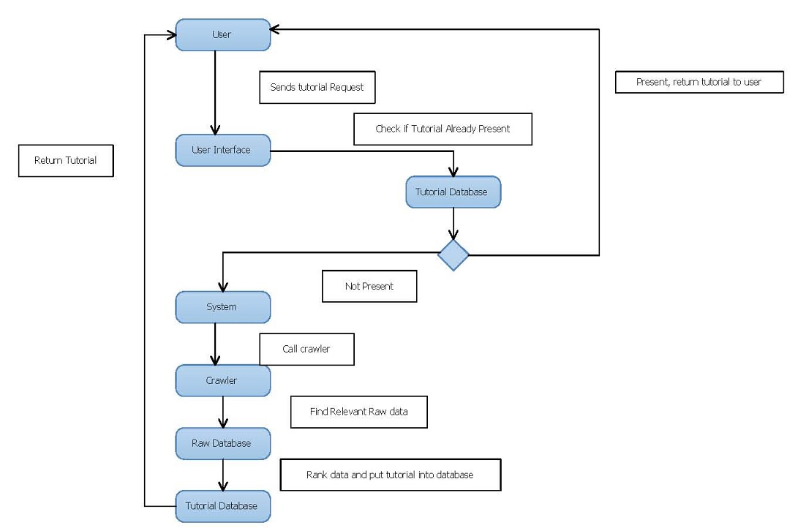

Methodology

- Databases

The system has a set of databases for:

I. storing details about every user like login details and other preferences
II. Storing subjects and streams
III. Storing sets of pages from which to collect terms and one for terms
IV. Storing a set of relevant pages and their scores
V. A cache for recently searched tutorials

User Input System

The user has access to the system via the browser which holds an interface designed in HTML, CSS. The user can view snippets of tutorials but has to login to actually view or search for any tutorial that he wants. Once the user logs in he can start a search by providing a stream and a subject for which he wants to search.

Tutorial Cache and Database
The system then checks the cache for previously searched tutorials and finds if there are any tutorials stored in the database cache already for the subject currently being searched for are retrieved and presented to the user.

Web Crawler
If the system fails to find the tutorial in the cache it will then enter the internet to prepare a tutorial for the user.
The system will first take a set of pages from the internet which hold the “subject” given by the user and will check if these pages hold the “subject” a certain threshold value of times or more and if they do use these pages to decide the relevancy terms for the document
Using these relevancy pages a set of terms are generated by finding the total presence of the terms in all the documents selected from above and then selecting the terms which are present in a “term-limit” number of documents or more.
Once the terms are selected the web crawler again starts crawling the internet looking for data which is relevant to the subject by cross referencing the “terms” selected above and we then take all documents which have a relevancy score above a certain relevancy limit and the system stores all such pages along with their relevancy scores into a database

Data Ranking Algorithm

Once the web crawler finds the relevant pages and their appropriate scores the data ranking algorithm is run to find out the total score of each document and take the highest scoring document as the final tutorial to be presented to the user.
The Data Ranking Algorithm will use the following criteria the implementation details of which are given below.

Ease of Understandability

To check if a piece of text is easily understandable or not we compare the text with a text or language corpus and based on the word scores of the words used we can generate an average understandability score for every document.

EoU Score= (avg. understandability % of document)

Diagrams

The diagrams in the data derived from the crawler are found and then an average score of total diagrams to length of document is found and applied to the ranking.

Diag. Score= (No Of Diagrams)

Descriptivity

To find out how descriptive or comparative a particular tutorial is we can use a very fixed corpus which contains the words “ like”, “can be compared to”, “is similar to”, “works like a”, etc.

Desc. Score= (No of Descriptive Parts*100)/total length

Examples and Solved Problems

Examples or solved problems are very clearly defined and can be easily found because they are preceded by very clear demarcations like “eg:”,”Solving”, etc .

Ex. Score= (No of Examples*100)/total length

Comments

The Subjectivity Lexicon from MPQA provides a list of words and their sentiments (positive, negative, neutral, or both) and using the same we can find out whether the comments convey a strong emotions about the text and accordingly decrease or increase its ranking
Com. Score= ((Number of Positive Comments) - (Number of Negative comments)).

EXPERIMENTAL RESULTS

To test the performance and accuracy of the Tutorial Builder Application, we used a predefined sample set of 11 documents. These were stored in a separate database from where the webcrawler can search for and sort through the documents to select the most relevant documents.

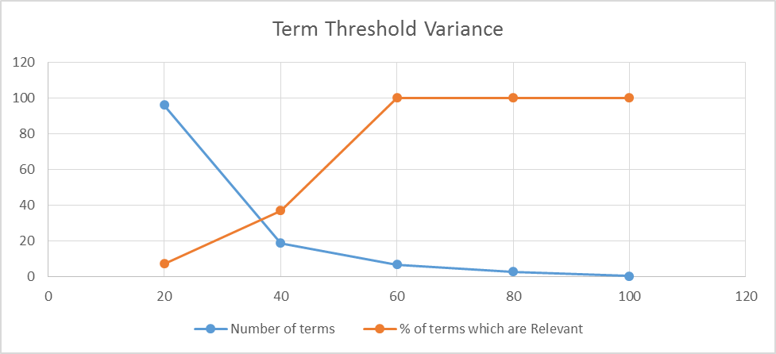
In Figure 5.1 we have demonstrated the threshold frequency of a term in the term data set for the term to be chosen and we can derive that a term that is in 60% of the selected documents is relevant and when 60% is chosen as a term threshold we get the maximum number of relevant terms as well.

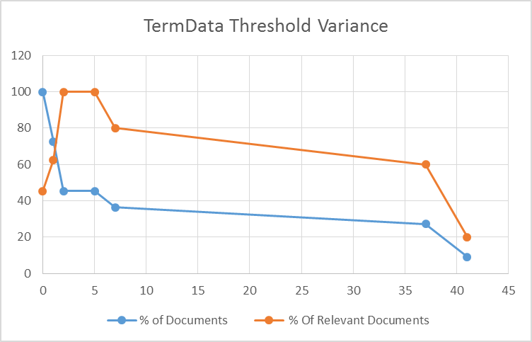

The Fig 5.2 shows term data threshold variance which contains the threshold number of times the subject name should appear in a document for it to be considered for term finding. As the graph shows the % of relevant documents initially increase with a higher threshold but on taking a higher threshold value the % of relevant documents decreases our experiments lead us to take the termdata threshold as 5.

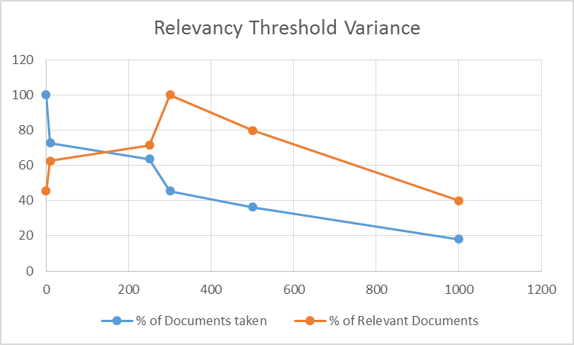

The Fig 5.3 shows relevancy threshold variance which contains the relevancy limit of a document, i.e. the number of terms a document should have so that it can be considered relevant to the topic and thus be taken for data ranking. The lower the threshold the higher number of irrelevant documents that enter into the data ranking algorithm and are considered for the final tutorial but if the threshold value is too high then we might end up ignoring tutorials which are good and relevant enough to the topic, from the experiments taken we found a threshold value of 350 to be a find demarkation of the tutorials into relevant and irrelevant.

Conclusion and future work
While our project has had certain success in this domain of Tutorial Building, it is not without pitfalls. It works well in the simulated environment that we have created, but is yet to be tested on the open internet.
Further, the application does not support the option of subtopics for the user to enter. By taking in the subtopics, the application can selectively search for tutorials based on those subtopics, rather than just based on the stream. This would result in independent searches for the separate subtopics allowing the application to merge the independent results together to ‘build’ the final tutorial.
Machine learning could be incorporated into the crawler so that it can extract only the relevant information from the websites, making the subsequent data ranking and crawling more efficient.
References
- Automated Essay Scoring Using Machine Learning - Shihui Song, Jason Zhao
- A Machine Learning Approach to WebpageContent Extraction - Jiawei YaoDepartment ofCSStanford University, XinhuiZuoDepartment of MS&EStanford University
- SubjectivityWord Sense Disambiguation - CemAkkaya and JanyceWiebe University of Pittsburgh, RadaMihalceaUniversity of North Texas
- Context based Re-ranking of Web Documents (CReWD) - Arijit Banerjee, JagadishVenkatraman Graduate Students, Department of Computer Science, Stanford UniversityAidan Hogan, Andreas Harth, and Stefan Decker
- Java Tutorials [http://www.java2s.com/]
- MySQL Tutorials [http://www.tutorialspoint.com/mysql/]

 

